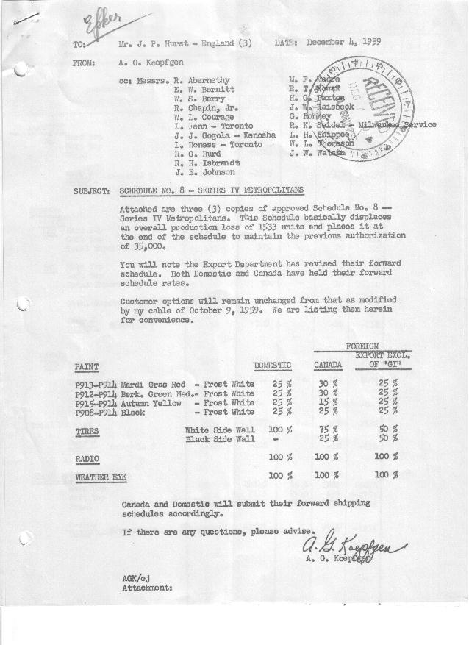

FORM AM 1262 Page 1 of 2 APPROVED R. Abernethy (signed) DATE 12-4-59

SCHEDULE NO. ______8 ___ DATE 12-4-59 MONTHLY BUILDING SCHEDULE APPROVED E.W.Bernitt (signed) DATE_ 12-4-59 _
REVISION NO. _______ __ ____ DATE PRODUCT APPROVED R. W.Chapin Jr. (signed) DATE _ 12/4/59 ____
SERIES IV 1500 c.c. ENGINE
METROPOLITAN SERIES CARS – AUSTIN MOTORS CO., LTD, ENGLAND
DESCRIPTION | BUILT  ◻ACT EST  THRU  NOV. | FIRM BUILDING SCHEDULE  (FABRICATED MATERIAL RELEASE) |  |  |  |  |  |  |  |  |  |  |  |  |  |  | TENTATIVE SCHEDULE  (RAW MATERIAL RELEASED) |  |  | GRAND  TOTAL
DESCRIPTION | BUILT  ◻ACT EST  THRU  NOV. | MONTH DECEMBER  DAYS 21 |  |  | MONTH JANUARY ‘60  DAYS 21 |  |  | MONTH FEBRUARY ‘60  DAYS 21 |  |  | MONTH MARCH ‘60  DAYS 23 |  |  | MONTH APRIL ‘60  DAYS 19 |  |  | MONTH MAY  DAYS 22 |  |  | GRAND  TOTAL
DESCRIPTION | BUILT  ◻ACT EST  THRU  NOV. | DAILY | MONTH | CUM’L  TOTAL | DAILY | MONTH | CUM’L  TOTAL | DAILY | MONTH | CUM’L  TOTAL | DAILY | MONTH | CUM’L  TOTAL | DAILY | MONTH | CUM’L  TOTAL | DAILY | MONTH | CUM’L TOTAL | GRAND  TOTAL
DOMESTIC LHD:
Hard-Top | 14222 |  | 1726 | 15948 |  | 1452 | 17400 |  | 1642 | 19042 |  | 1659 | 20701 |  | 1462 | 22163 |  | 1751 | 23914
Soft-Top | 3872 |  | 329 | 4201 |  | 622 | 4823 |  | 703 | 5526 |  | 711 | 6237 |  | 488 | 6725 |  | 584 | 7309
Total U.S. | 18094 | 97.8 | 2055 | 20149 | 98.8 | 2074 | 22223 | 111.7 | 2345 | 24568 | 103.1 | 2370 | 26938 | 102.6 | 1950 | 28888 | 106.1 | 2335 | 31223
Over/(Under) Schedule 7 | (1475) |  | -0- | (1475) |  | -0- | (1475) |  | -0- | (1475) |  | -0- | (1475) |  | -0- | (1475) |  | 378 | (1097)
FOREIGN:
EXPORT LHD Hard-Top | 210 |  | 14 | 224 |  | 14 | 238 |  | 14 | 252 |  | 14 | 266 |  | 14 | 280 |  | 14 | 294
Soft-Top | 65 |  | 6 | 71 |  | 6 | 77 |  | 6 | 83 |  | 6 | 89 |  | 6 | 95 |  | 6 | 101
Total Export LHD | 275 |  | 20 | 295 |  | 20 | 315 |  | 20 | 335 |  | 20 | 355 |  | 20 | 375 |  | 20 | 395
RHD Hard Top | 26 |  | 7 | 33 |  | 7 | 40 |  | 7 | 47 |  | 7 | 54 |  | 7 | 61 |  | 7 | 68
Soft Top | 14 |  | 3 | 17 |  | 3 | 20 |  | 3 | 23 |  | 3 | 26 |  | 3 | 29 |  | 3 | 32
Total Export RHD | 40 |  | 10 | 50 |  | 10 | 60 |  | 10 | 70 |  | 10 | 80 |  | 10 | 90 |  | 10 | 100
Total Export LHD & RHD | 315 | 1.4 | 30 | 345 | 1.4 | 30 | 375 | 1.4 | 30 | 405 | 1.3 | 30 | 435 | 1.6 | 30 | 465 | 1.4 | 30 | 495
Over/(Under) Schedule 7 | (58) |  | (10) | (68) |  | (10) | (78) |  | (10) | (88) |  | (10) | (98) |  | (10) | (108) |  | (10) | (118)
CANADA Hard-Top | 1222 |  | 50 | 1272 |  | 30 | 1302 |  | 30 | 1332 |  | 170 | 1502 |  | 140 | 1642 |  | 110 | 1752
Soft-Top | 150 |  | -0- | 150 |  | -0- | 150 |  | -0- | 150 |  | 65 | 215 |  | 55 | 270 |  | 45 | 315
Total Canada | 1372 | 2.4 | 50 | 1422 | 1.4 | 30 | 1452 | 1.4 | 30 | 1482 | 10.2 | 235 | 1717 | 10.3 | 195 | 1912 | 7.0 | 155 | 2067
Over/(Under) Schedule 7 | -0- |  | -0- | -0- |  | -0- | -0- |  | -0- | -0- |  | -0- | -0- |  | -0- | -0- |  | -0- | -0-
Total Foreign | 1687 | 3.8 | 80 | 1767 | 2.8 | 60 | 1827 | 2.8 | 60 | 1887 | 11.5 | 265 | 2152 | 11.9 | 225 | 2377 | 8.4 | 185 | 2562
Over/(Under) Schedule 7 | (58) |  | (10) | (68) |  | (10) | (78) |  | (10) | (88) |  | (10) | (98) |  | (10) | (108) |  | (10) | (118)
GRAND TOTALS
Hard-Top | 15680 | 85.6 | 1797 | 17477 | 71.6 | 1503 | 18980 | 80.6 | 1693 | 20673 | 80.4 | 1850 | 22523 | 85.4 | 1623 | 24146 | 85.5 | 1882 | 26028
Soft-Top | 4101 | 16.1 | 338 | 4439 | 30.0 | 631 | 5070 | 33.9 | 712 | 5782 | 34.2 | 785 | 6567 | 29.1 | 552 | 7119 | 29.0 | 638 | 7757
Total | 19781 | 101.7 | 2135 | 21916 | 101.6 | 2134 | 24050 | 114.5 | 2405 | 26455 | 114.6 | 2635 | 29090 | 114.5 | 2175 | 31265 | 114.5 | 2520 | 33785
Over/(Under) Schedule 7 | (1533) |  | (10) | (1543) |  | (10) | (1553) |  | (10) | (1563) |  | (10) | (1573) |  | (10) | (1583) |  | 368 | (1215)

FORM AM 1262 Page 2 of 2 APPROVED R. Abernethy (signed) DATE 12-4-59

SCHEDULE NO. ______8 ___ DATE 12-4-59 MONTHLY BUILDING SCHEDULE APPROVED E.W.Bernitt (signed) DATE_ 12-4-59 _
REVISION NO. _______ __ ____ DATE PRODUCT APPROVED R. W.Chapin Jr. (signed) DATE _ 12/4/59 ____
SERIES IV 1500 c.c. ENGINE
METROPOLITAN SERIES CARS – AUSTIN MOTORS CO., LTD, ENGLAND
DESCRIPTION | BUILT  ◻ACT◻ EST  THRU  NOV. | FIRM BUILDING SCHEDULE  (FABRICATED MATERIAL RELEASE) |  |  |  |  |  |  |  |  |  |  |  |  |  |  | TENTATIVE SCHEDULE  (RAW MATERIAL RELEASED) |  |  | GRAND  TOTAL
DESCRIPTION | BUILT  ◻ACT◻ EST  THRU  NOV. | MONTH JUNE  DAYS 11 Days (20 Avail) |  |  | MONTH  DAYS |  |  | MONTH  DAYS |  |  | MONTH  DAYS |  |  | MONTH  DAYS |  |  | MONTH  DAYS |  |  | GRAND  TOTAL
DESCRIPTION | BUILT  ◻ACT◻ EST  THRU  NOV. | DAILY | MONTH | CUM’L  TOTAL | DAILY | MONTH | CUM’L  TOTAL | DAILY | MONTH | CUM’L  TOTAL | DAILY | MONTH | CUM’L  TOTAL | DAILY | MONTH | CUM’L  TOTAL | DAILY | MONTH | CUM’L TOTAL | GRAND  TOTAL
DOMESTIC LHD:
Hard-Top |  |  | 780 | 24694
Soft-Top |  |  | 260 | 7569
Total U.S. |  | 98.0 | 1040 | 32263
Over/(Under) Schedule 7 |  |  | 1040 | (57)
FOREIGN:
EXPORT LHD Hard-Top |  |  | 14 | 308
Soft-Top |  |  | 6 | 107
Total Export LHD |  |  | 20 | 415
RHD Hard Top |  |  | 7 | 75
Soft Top |  |  | 3 | 35
Total Export RHD |  |  | 10 | 110
Total Export LHD & RHD |  | 2.8 | 30 | 525
Over/(Under) Schedule 7 |  |  | 30 | (88)
CANADA Hard-Top |  |  | 145 | 1897
Soft-Top |  |  | 0 | 315
Total Canada |  | 13.7 | 145 | 2212
Over/(Under) Schedule 7 |  |  | 145 | 145
Total Foreign |  | 16.5 | 175 | 2737
Over/(Under) Schedule 7 |  |  | 175 | 57
GRAND TOTALS
Hard-Top |  | 89.2 | 946 | 26974
Soft-Top |  | 25.3 | 269 | 8026
Total |  | 114.5 | 1215 | 35000
Over/(Under) Schedule 7 |  |  | 1215 | -0-

